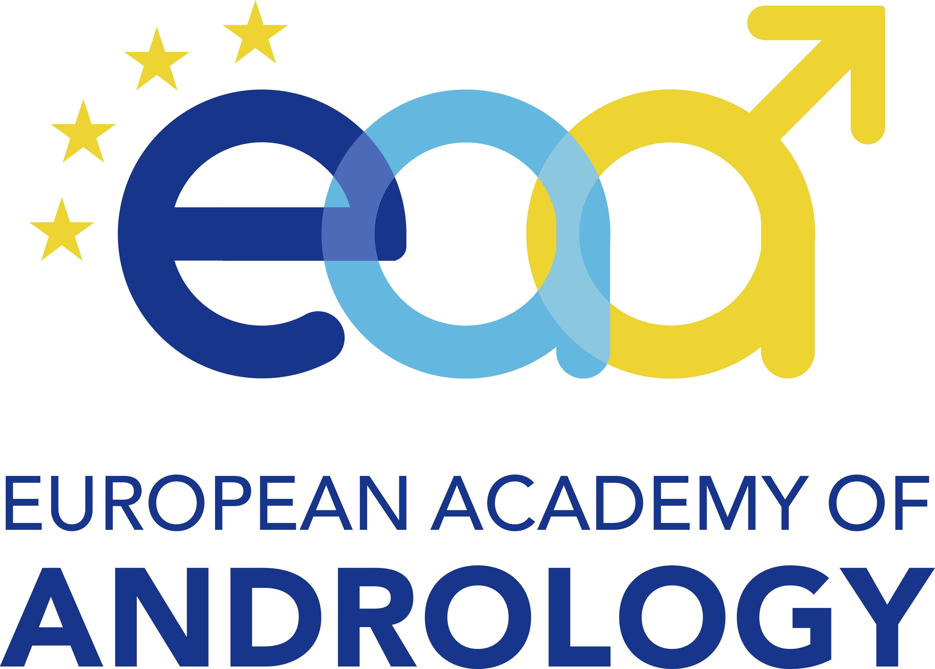**EAA Travel Grant 2025  
dedicated to the 34th Summer Academy – CeRA Münster**

**Application Form**

**Deadline for application: 10 September 2025**

**Please complete the application electronically and submit it as a single PDF file to the EAA Office (office@andrologyacademy.net). The PDF must include the completed application form and short CV listing your publications from the last 3 years only. The selection decision will be communicated a few days after the submission deadline.**

**Applicant details**

Name of Applicant: **...........................................**

Department’s name and address: ................................................................................

.........................................................................................................................

Country of Residence: ...............................................

Date of birth *(priority for applicants below 45 years of age):*  .........................

Email: ........................................

**Membership**

I am a member of the EAA with all annual fees paid, since year: .............

I confirm that I paid the EAA membership fees for 2024/2025: YES/NO (please underline your  
 answer)

*Please note: Payment of the membership fee is a prerequisite for this application.*

**Amount applied for (grant will be provided on reimbursement basis, up to € 350):**

€ ............. (please enter the maximum amount of €350 if travel costs are not yet known)

|  |
| --- |
| **Grant payment information** |

Payments to an institutional or personal bank account *(please fill up the information below)* will be made upon the presentation of the documentation of the costs (receipts). The awardee is personally responsible for all tax matters in his/her own country.

|  |  |
| --- | --- |
| Account holder’s name |  |
| Bank |  |
| IBAN(Internat. Bank Account No.) |  |
| SWIFT/BIC code (bank identifier) |  |
| Bank sort code (if UK bank) |  |
| Other information (if needed) |  |