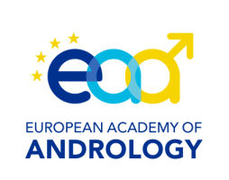
www.andrologyacademy.net
EAA Ultrasound Course Application form
EAA Ultra

Application deadline: January 13, 2023. Every year maximum 8 fellows
The first 8 people who will send the application form will attend the course (EAA affiliated members have a priority access to the course).

This application must be completed electronically and submitted to the Secretariat Office, office@andrologyacademy.net and in c/c to
Francesco Lotti (francesco.lotti@unifi.it) and Andrea M. Isidori (andrea.isidori@uniroma1.it)

The course is held jointly by the EAA Training Centers of Florence and Rome. Decision on the applications will be taken within two weeks after the deadline.
1. Applicant details

Name
Date of birth
Department
Postal address
Country of residence
E-mail
2. Membership
EAA member with annual fees paid, since year
3. Brief Curriculum Vitae an publication record
Please:
-attach a brief CV
-attach publication record
4. Fee information

Academy members 700 Euros
Others………………………..1400 Euros
5. Check list (please, tick ALL lines)

YES | NO
 |  | I am a current member of the EAA
 |  | I am a fellow in training for the “Clinical Andrologist Exam”(certificate from the Center director is required)
 |  | I understand there is a Course Fee to be paid that will only cover the teaching material (not accommodation/travel/food)
 |  | I understand 25 EAA credits must be collected to obtain EAA ultrasound certification.
 |  | I understand it is not required to collect “consecutive” credits.
 |  | I understand “practical part” lasts 4 weeks, either consecutive or 4 times one week, upon agreement with the fellow and it is held in EAA Centers of Florence and Rome
 |  | I understand there is an initial theoretical part made of frontal lessons and videos that will be held in a single day and will host all the fellows.
 |  | I have attached to the present form the CV and publication record

Signature |  | Date

